Lab Exercise 5- Building a Complex Electromechanical Model in OMEdit

LAB EXPERIMENT
Building a Complex Electromechanical Model in OMEdit
DC Motor Driven Rotational Load

1. AIM
To build and simulate a multi-domain electromechanical system in OMEdit by combining electrical and mechanical domains and to understand the complete mathematical energy flow.
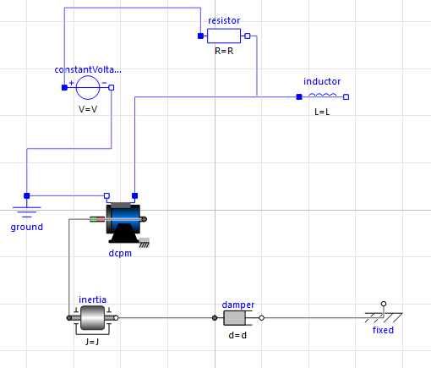

2. OBJECTIVE
After completing this experiment, students will be able to:
• Combine electrical and mechanical domains
• Configure DC_PermanentMagnet motor correctly
• Understand internal coupling equations
• Perform simulation with proper solver settings
• Interpret electromechanical transient behavior
Real-Life Example
It works like:
• A ceiling fan
• A water pump
• An electric drill
• A robotic motor
When you turn it on:
It starts fast, then stabilizes.

3. SYSTEM OVERVIEW
The system represents a 24V DC motor driving a rotational mechanical load.
Energy Flow:
Electrical Energy → Magnetic Field → Torque → Mechanical Rotation

4. COMPONENTS USED (Correct Library Path)
Electrical Components
Modelica → Electrical → Analog
• Sources → ConstantVoltage
• Basic → Resistor
• Basic → Inductor
• Basic → Ground
Motor Component
Modelica → Electrical → Machines → BasicMachines → DCMachines
• DC_PermanentMagnet
Mechanical Components
Modelica → Mechanics → Rotational → Components
• Inertia
• Damper
• Fixed

5. STEP-BY-STEP PROCEDURE

STEP 1: Launch OMEdit
Open OpenModelica and launch OMEdit graphical interface.

STEP 2: Create a New Model
Click File → New Modelica Class.
Name the model: ElectromechanicalSystem.
Select restriction: model.
Click OK.

STEP 3: Add Electrical Voltage Source
Navigate to Modelica → Electrical → Analog → Sources.
Drag and drop ConstantVoltage into the diagram.
Double-click and set:
V = 24 V
Explanation:
This provides constant DC electrical supply.

STEP 4: Add Electrical Resistor
Navigate to Modelica → Electrical → Analog → Basic.
Drag Resistor into diagram.
Set:
R = 2 Ω
Explanation:
This limits current and represents armature resistance external to motor.

STEP 5: Add Electrical Inductor
From the same Basic package, drag Inductor.
Set:
L = 0.5 H
Explanation:
This represents electrical inductance that resists sudden current change.

STEP 6: Add Ground
Drag Ground from Basic package.
Explanation:
Ground provides electrical reference and completes the circuit.

STEP 7: Add DC Motor
Navigate to Modelica → Electrical → Machines → BasicMachines → DCMachines.
Drag DC_PermanentMagnet into diagram.

STEP 8: Configure DC Motor (General Tab)
Open General tab.
Set:
Jr = 0.01 kg·m²
Js = 0
Explanation:
Jr represents rotor inertia.

STEP 9: Configure DC Motor (Armature Tab)
Open Armature tab.
Set:
Ra = 1 Ω
La = 0.5 H
Explanation:
Ra represents internal armature resistance.
La represents armature inductance.

STEP 10: Configure DC Motor (Nominal Parameters Tab)
Open Nominal parameters tab.
Set:
VaNominal = 24 V
IaNominal = 10 A
wNominal = 1500 rev/min
TaNominal = 25 °C
Explanation:
Torque constant (Kt) and back EMF constant (Ke) are internally derived from these nominal values.

STEP 11: Add Mechanical Inertia
Navigate to Modelica → Mechanics → Rotational → Components.
Drag Inertia into diagram.
Set:
J = 0.02 kg·m²
Explanation:
Represents mechanical load inertia.

STEP 12: Add Mechanical Damper
Drag Damper component.
Set:
d = 0.1 N·m·s
Explanation:
Represents friction and mechanical losses.

STEP 13: Add Fixed Support
Drag Fixed component.
Explanation:
Provides mechanical reference point.

STEP 14: Make Electrical Connections
Connect Voltage.p → Resistor.p
Connect Resistor.n → Inductor.p
Connect Inductor.n → motor.pin_ap
Connect motor.pin_an → Ground.p
Connect Voltage.n → Ground.p
Explanation:
Completes electrical armature circuit.

STEP 15: Make Mechanical Connections
Connect motor.flange → load.flange_a
Connect load.flange_b → damper.flange_a
Connect damper.flange_b → fixed.flange
Explanation:
Transfers torque from motor to load.

6. COMPLETE MATHEMATICAL FLOW

STEP 16: Electrical Equation
V = R_total * i + L_total * (di/dt) + Ke * ω
Where:
R_total = 2 + Ra
L_total = 0.5 + La
Explanation:
Voltage balances resistive drop, inductive drop, and back EMF.

STEP 17: Back EMF Equation
E_back = Ke * ω
Explanation:
Speed generates opposing voltage.

STEP 18: Torque Equation
T = Kt * i
Explanation:
Current produces torque.

STEP 19: Mechanical Equation
(J_total) * (dω/dt) = T − Bω
Where:
J_total = Jr + Load J
Explanation:
Torque accelerates rotor; damper resists motion.

STEP 20: Understand Startup Behavior
At t = 0:
ω = 0
Back EMF = 0
Current = Maximum
Torque = Maximum
As ω increases:
Back EMF increases
Current decreases
Torque decreases
System stabilizes when torque equals damping load.

7. SIMULATION SETTINGS

STEP 21: Open Simulation Setup
Right-click model → Simulation Setup.

STEP 22: Set Simulation Parameters
Start Time = 0
Stop Time = 5
Click Simulate.

8. RESULT VISUALIZATION

STEP 23: Plot Electrical Current
Select:
motor.pin_ap.i
Expected:
High initial current spike.

STEP 24: Plot Angular Speed
Select:
motor.w
Expected:
Gradual increase to steady state.

STEP 25: Plot Electromagnetic Torque
Select:
motor.tauElectrical
Expected:
High at startup, decreases later.

9. ENERGY FLOW ANALYSIS
Electrical Power:
P = V * i
Mechanical Power:
P = T * ω
Losses:
I²R loss
Mechanical damping loss

10. CONCLUSION
This experiment demonstrates true multi-domain modeling in OMEdit where electrical and mechanical physics are coupled automatically and solved simultaneously.

